Gabe Maturo

IS420

2/5/2021

Assignment 1

Table Creation

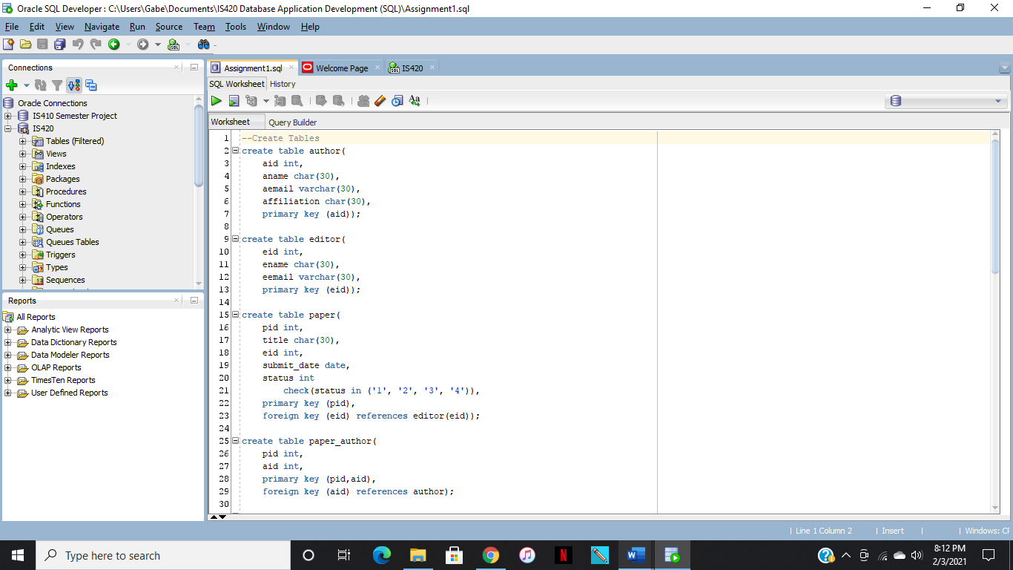

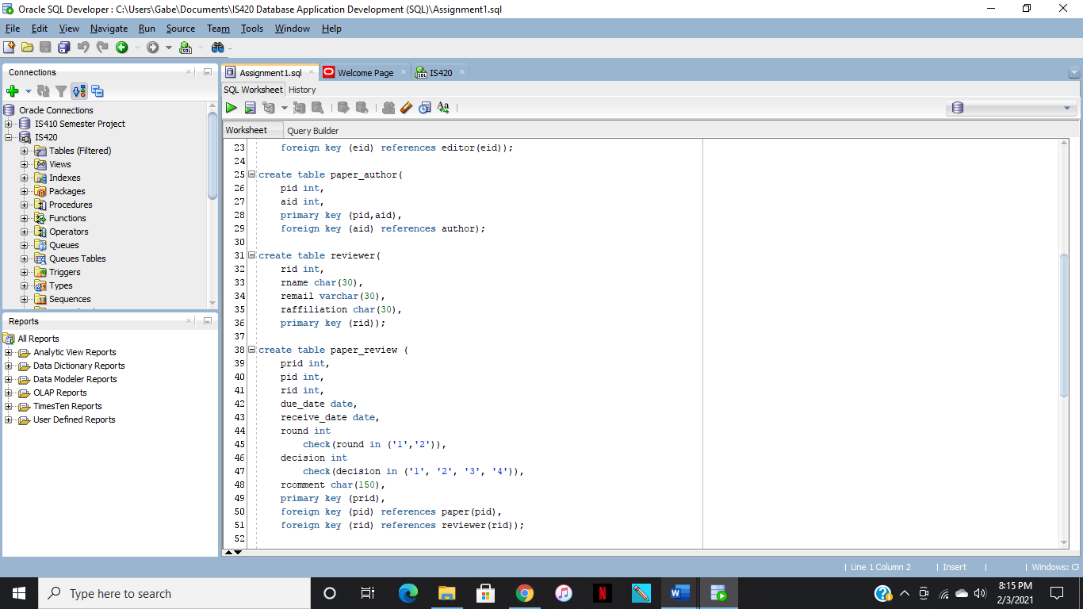

Insert 3 Rows of Data

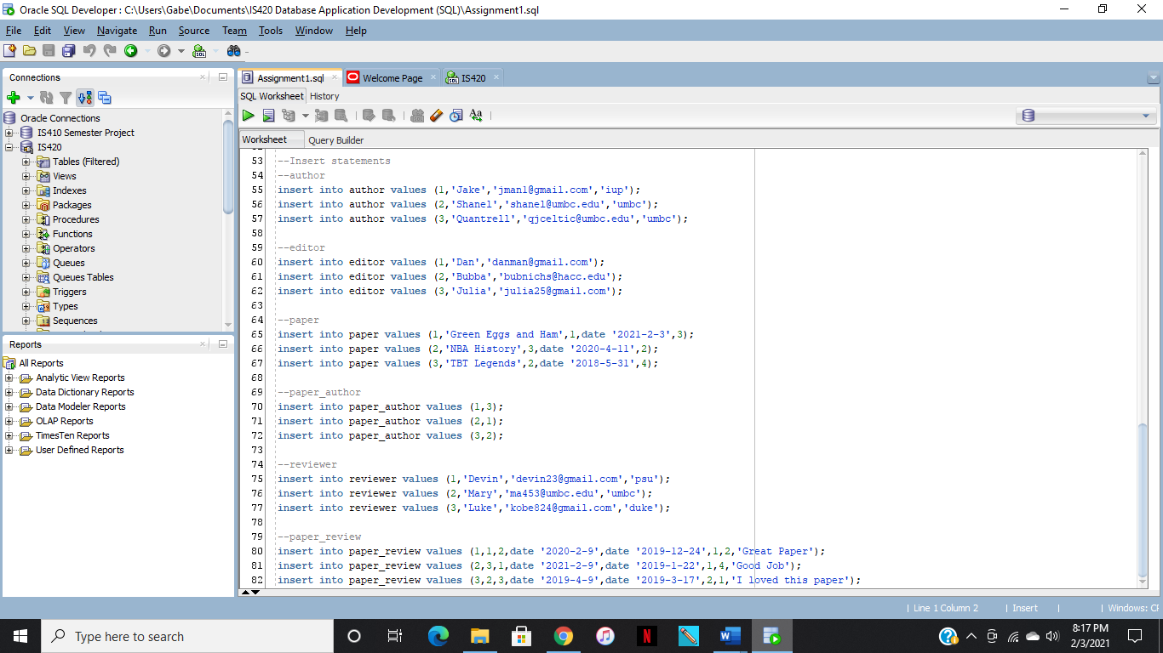

Results for Data in Tables

Author

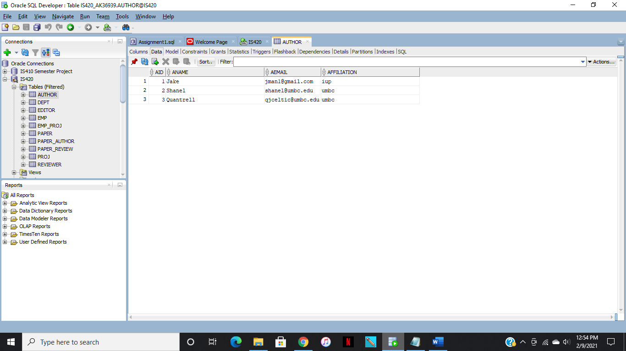

Editor

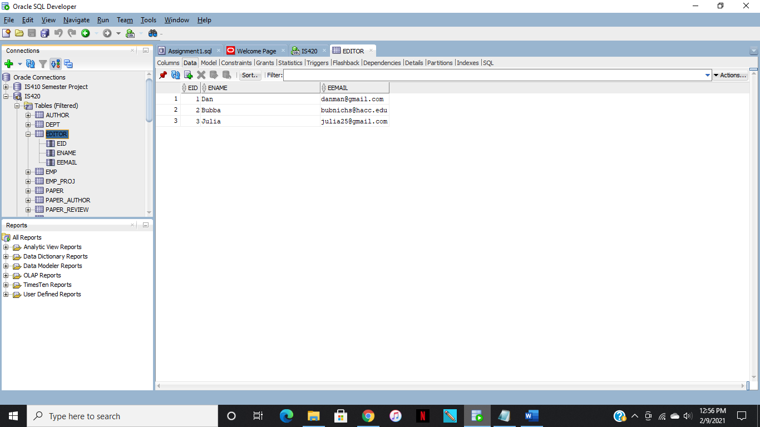

Paper

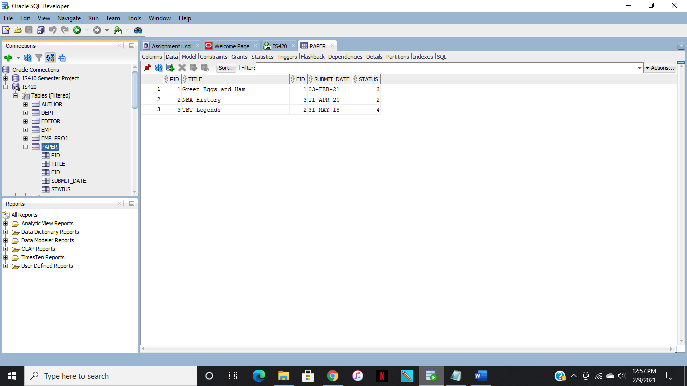

Paper_author

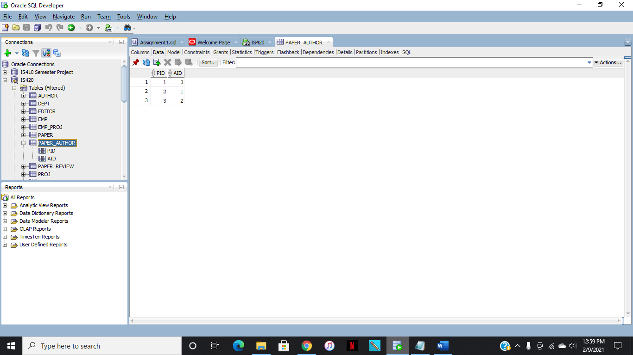

Reviewer

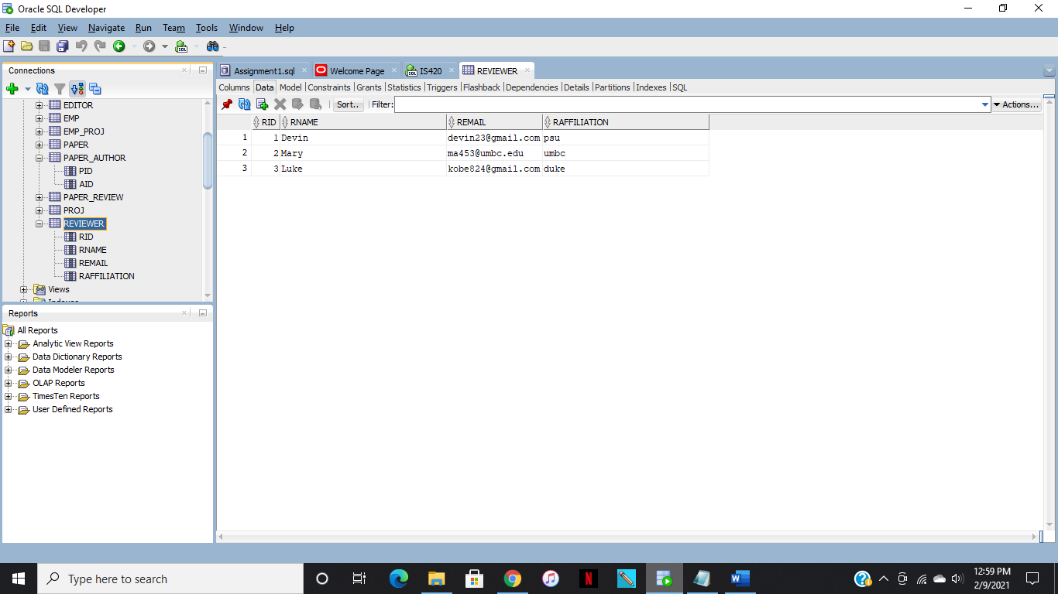

Paper_review

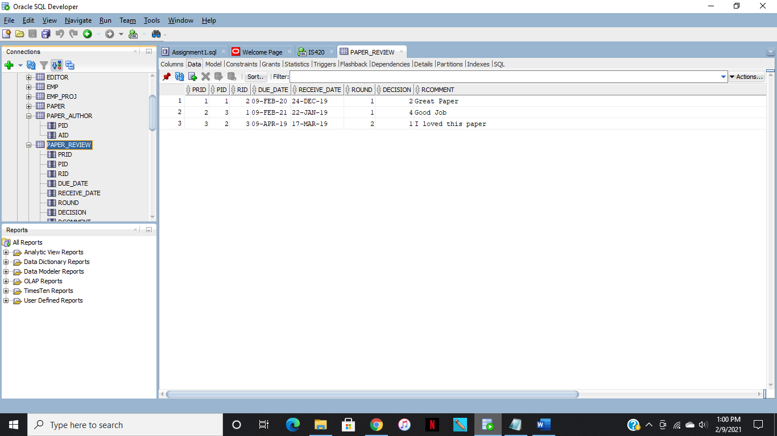

Code

--Drop Tables (if needed)

drop table paper_review;

drop table paper_author;

drop table paper;

drop table author;

drop table editor;

drop table reviewer;

--Create Tables

create table author(

aid int,

aname char(30),

aemail varchar(30),

affiliation char(30),

primary key (aid));

create table editor(

eid int,

ename char(30),

eemail varchar(30),

primary key (eid));

create table paper(

pid int,

title char(30),

eid int,

submit_date date,

status int

check(status in ('1', '2', '3', '4')),

primary key (pid),

foreign key (eid) references editor(eid));

create table paper_author(

pid int,

aid int,

primary key (pid,aid),

foreign key (aid) references author);

create table reviewer(

rid int,

rname char(30),

remail varchar(30),

raffiliation char(30),

primary key (rid));

create table paper_review (

prid int,

pid int,

rid int,

due_date date,

receive_date date,

round int

check(round in ('1','2')),

decision int

check(decision in ('1', '2', '3', '4')),

rcomment char(150),

primary key (prid),

foreign key (pid) references paper(pid),

foreign key (rid) references reviewer(rid));

--Insert statements

--author

insert into author values (1,'Jake','jman1@gmail.com','iup');

insert into author values (2,'Shanel','shanel@umbc.edu','umbc');

insert into author values (3,'Quantrell','qjceltic@umbc.edu','umbc');

--editor

insert into editor values (1,'Dan','danman@gmail.com');

insert into editor values (2,'Bubba','bubnichs@hacc.edu');

insert into editor values (3,'Julia','julia25@gmail.com');

--paper

insert into paper values (1,'Green Eggs and Ham',1,date '2021-2-3',3);

insert into paper values (2,'NBA History',3,date '2020-4-11',2);

insert into paper values (3,'TBT Legends',2,date '2018-5-31',4);

--paper_author

insert into paper_author values (1,3);

insert into paper_author values (2,1);

insert into paper_author values (3,2);

--reviewer

insert into reviewer values (1,'Devin','devin23@gmail.com','psu');

insert into reviewer values (2,'Mary','ma453@umbc.edu','umbc');

insert into reviewer values (3,'Luke','kobe824@gmail.com','duke');

--paper_review

insert into paper_review values (1,1,2,date '2020-2-9',date '2019-12-24',1,2,'Great Paper');

insert into paper_review values (2,3,1,date '2021-2-9',date '2019-1-22',1,4,'Good Job');

insert into paper_review values (3,2,3,date '2019-4-9',date '2019-3-17',2,1,'I loved this paper');